Review II

1. Determine whether the expression is a tautology:
2. – (P & - P)
3. P v ( P & - P )
4. – [ P v ( P & Q) ] v P
5. [ ( P → Q ) → P ] → P
6. P → [ Q → ( P & Q ) ]
7. Determine whether the expression is a contradiction:
8. – ( P v – P )
9. [ P & ( Q v P ) ] & - P
10. – [ - ( P → Q ) → P

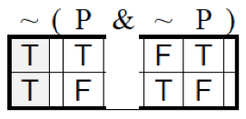

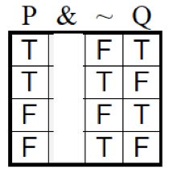

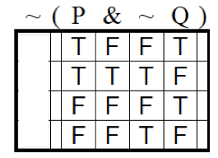

Use the truth tree method

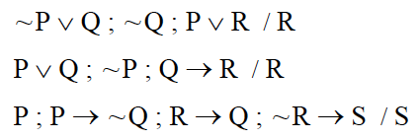

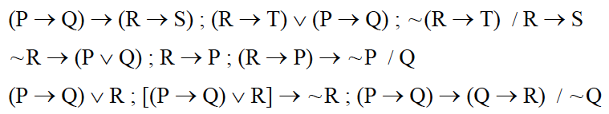

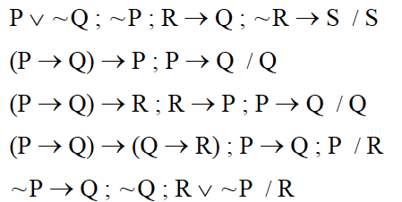Macintosh HD:Users:kamillasmith:Desktop:Screen shot 2016-04-23 at 2.34.27 PM.pngMacintosh HD:Users:kamillasmith:Desktop:Screen shot 2016-04-23 at 2.34.27 PM.png

